<Name of Information System>

Version 1.0

REVISION HISTORY
Version | Date | Author | Notes
0.1 | dd mmm yyyy |  | Initial Draft

This document aims to provide a detailed design specification for the realization of requirements of the system to be developed. This will establish a clear perspective of the product’s features and functions that will serve as the basis for its implementation, tool for validation, and as reference during maintenance.

PROJECT IDENTIFICATION
System Name
System ID |  |  |  | System Owner
<acronym>-<2-digit year>
Project Leader |  |  |  | System Designer
Lead Developer |  |  |  | System Developer
Quality Assurance Lead |  |  |  | Quality Assurance Analyst/Engineer
Security Analyst |  |  |  | Document Analyst
PROJECT OVERVIEW
< Provide a short description of the system/product being specified and its purpose, including relevant benefits, objectives, and goals. Relate the software to corporate goals or business strategies.
Describe the scope of the project which describes the domain problem and what part of it will be addressed. If a separate version and scope document is available, refer to it rather than duplicating its contents here.
Describe the context and origin of the product. For example, state whether this product is a follow-on member of a product family, a replacement for certain existing systems, or a new, self-contained product. If this SDS will define a component of a larger system, relate the requirements of the larger system to the functionality of this software and identify interfaces between the two. A simple diagram that shows the major components of the overall system, subsystem interconnections, and external interfaces can be helpful. Use package diagram or deployment diagram.
Sample statements taken from PSIS project are given below. Do, where appropriate, add, modify, or delete the following statements.>
The DOST-CO Property and Supply Inventory System (PSIS) is a web-based software application designed to facilitate the monitoring of an agency's inventory of tangible assets in accordance with the guidelines and procedures prescribed in the FY 2016 Government Accounting Manual (GAM) for National Government Agencies.
The system covers activities performed by DOST-CO Property and Supply Section (PSS) in acquiring tangible properties from delivery to disposal. It aims to (a) accelerate tracking of semi-expendable and non-expendable properties; (b) automate manual-based counting and recording of stock balances of consumable supplies and materials; (c) maintain a complete and reliable record of accountabilities and history of consumption that will be used in strategic business decisions to control costs and efficiently allocate resources among the organization; and (d) readily produce pre-defined reports as needed.
REFERENCES
< List here any documents, websites, and other sources of information that have been referred to in the process of constructing this SDS. Provide enough information for easy retrieval. Refer to ITD IS Standards and Guidelines on how to lay out references. >
Information Technology Division, Planning and Evaluation Service, Department of Science and Technology Central Office. ITD Information Systems Development Standards & Guidelines, version 1.0, January 2020.
DEFINITION AND ACRONYMS
< Define only important unique or disputable terms and important unfamiliar or ambiguous acronyms or abbreviations in the following format below. >
Tangible Assets are the assets on a company's books and balance sheet that have a physical form. They comprise the machinery, office equipment and buildings used by a company (fixed assets) and of the materials that are used in producing products (current assets).
Purchase Order (PO) is a contract between the entity and the supplier for the delivery of specified items based on the stipulations stated which was agreed upon during the procurement process.
PRODUCT DESCRIPTION
< Summarize the major features the product contains or the significant functions that it performs or lets the user perform. Details will be provided in the conceptual design so only a high-level summary is needed here. Organize the functions to make them understandable to any reader of this document. A picture of the major groups of related requirements and how they relate, such as a top-level data flow diagram, a class diagram, or component diagram is often effective.
Sample statements and diagrams are given below. Do, where appropriate, add, modify, or delete the following statements. >
DOST-CO IS shall be divided into three (3) significant features/functions as presented in the component diagram below.
Feature 1. This feature pertains to ….

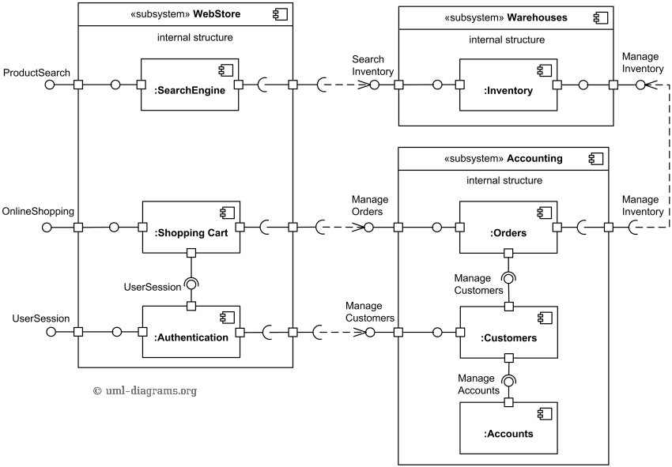

USER CHARACTERISTICS
< Identify the various user classes that you anticipate will use this product. User classes may be differentiated based on frequency of use, subset of product functions used, technical expertise, security or privilege levels, educational level, or experience. Describe the pertinent characteristics of each user class. Certain requirements may pertain only to certain user classes. Include training if possible. >
Class |  | Characteristics and Roles |  |  | Accessible Features
System Administrator |  | Lead personnel assigned to act as the System Administrator that will be responsible for the management and operation of the system.  There shall only be one (1) System Administrator |  |  | Shall have unrestricted access and control for the overall management and operation of the system.
SYSTEM RESOURCES
< Identify the resources and technology that are to be used for the implementation of the product development. Specify resources by category. If automated tools are to be used in developing, specify the source of the tools, availability, and the usage requirements.
Do, where appropriate, add, modify, or delete the appendices below. >
No. | Resources |  | Descriptions
1. | Server |  | Name : 10.10.10.00  Type : Web Server (Local Network)  OS : Ubuntu ver. 00
2. | Database |  | Name : 10.10.10.00  Type : Database Server  DBMS : MySQL ver. 00
3. | Development Tool |  | Name : PHP ver. 00  Type : Web Application Framework (Backend Scripting)  URL : https://www.php.net/  Name : CodeIgniter ver. 00  Type : PHP MVC Framework  URL : https://www.codeigniter.com/  Name : JQuery ver. 00  Type : Javascript Library (Frontend Scripting)  URL : https://jquery.com/
4. | Client |  | Name : Chrome ver. 00  Type : Web Browser  OS : Windows 10 ver. 00  URL : https://www.google.com/intl/en_ph/chrome/  Name : Firefox ver. 00  Type : Web Browser  OS : Windows 10 ver. 00  URL : https://www.mozilla.org/en-US/firefox/
5. | Network |  | Type : Ethernet LAN Gigabit  Speed : 100Mb/s
DETAILED DESIGN
Appendix A User Interface Design and Specifications
Appendix B Database Schema
Appendix C Data Dictionary
Appendix D Reports and Forms

Appendix A

User Interface
Design and Specifications

Appendix B

Database Schema

Appendix C

Data Dictionary

Appendix D

Reports and Forms

